First day. Strange rules.
Learner page 1 | Notice a problem, ask a question, explain a rule
You are visiting a shared workspace: a place where different people work. What helps everyone use it comfortably? All people, places and rules in this pack are fictional.
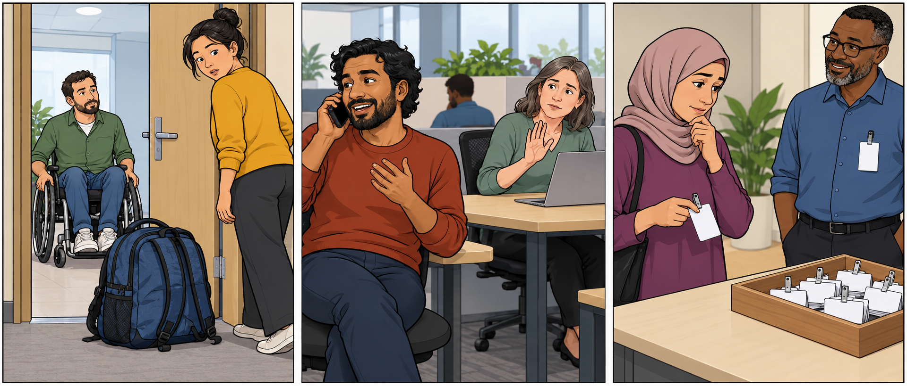

Look from left to right
1. What is happening in each picture? Say what you can see.
2. What problem might there be? Which action could help?
3. Which things need a clear rule? Which could be a choice? Explain your ideas.
The pictures do not show the official rules. You can have different ideas. You will check the actual workspace rules later.

Try saying it
People have to ______ because ______.
You mustn’t ______ here.
Do visitors have to ______?
I think ______ could be optional.
___________________________________________________________________
___________________________________________________________________
Think of a helpful or surprising rule you have met. Tell a partner why it existed. You may invent a story or pass.

Must have to or a choice
Read the signs. Say what each one means.
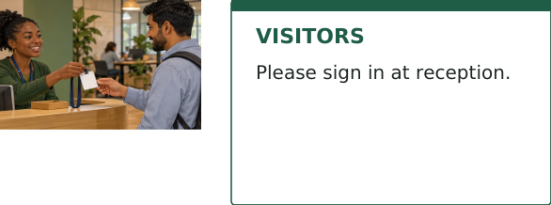 | You must / have to  It is necessary. Do it.  You must sign in.  You have to sign in.
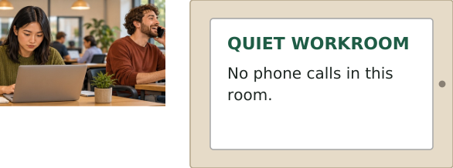 | You mustn’t  It is not allowed. Don’t do it.  You mustn’t make calls here.
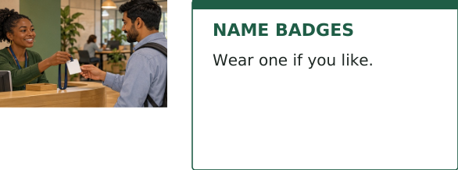 | You don’t have to  It is optional. You can choose.  You don’t have to wear a badge.
Must and have to both can mean “it is necessary”. You can often use either. Have to is common when we talk about rules; must is common in firm instructions.
Form: I have to / Sam has to sign in. I must / Sam must sign in.
Question: Do I have to sign in? Does Sam have to sign in?
Remember: must + verb, without to. Don’t have to does not mean mustn’t.

Choose the words
1. A badge is optional. You mustn’t / don’t have to wear one.
2. Calls are not allowed here. You mustn’t / don’t have to make calls.
3. Every visitor signs in. You must / mustn’t sign in.
4. Sam needs to sign in. Sam have to / has to sign in.

Is your friend right
You are visiting Green Door Studio. Read your friend’s texts and the studio signs.
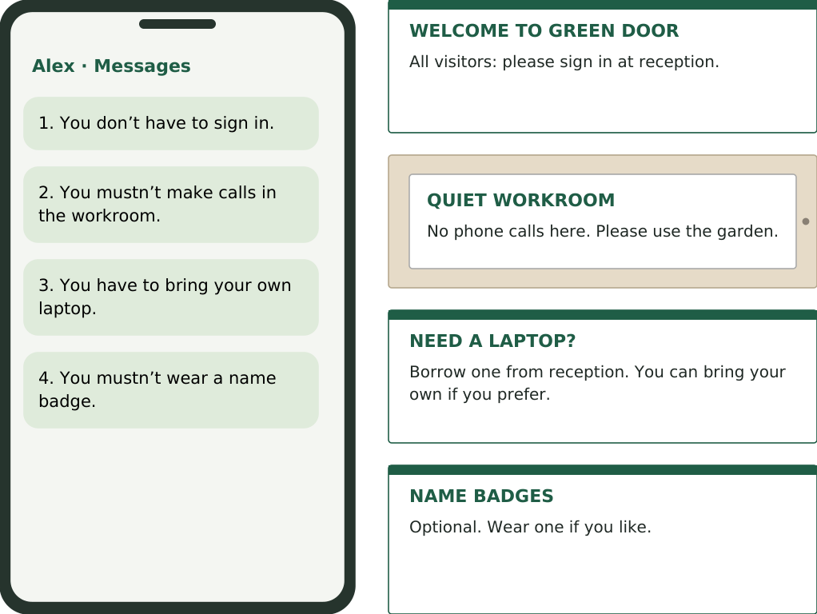

Check the four messages
Put a tick next to a correct message. Correct the other messages.
1. _________________________________________________________________
2. _________________________________________________________________
3. _________________________________________________________________
4. _________________________________________________________________
Now talk: A asks, “Do I have to bring a laptop?” B answers using a sign. Ask about all four things, then swap roles. Finish by giving Alex the correct advice.

Which rules make sense
Choose one place. Agree three useful rules: something necessary, something forbidden and something optional.
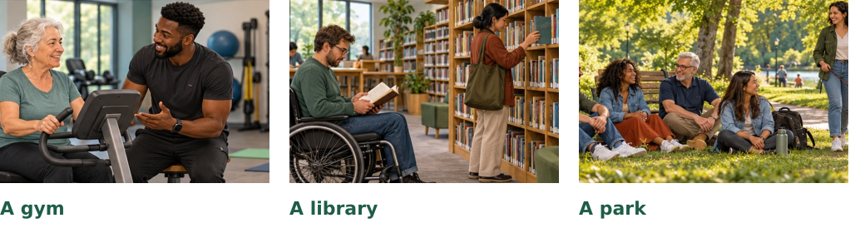
We have to… because… / We mustn’t… because… / We don’t have to…
Compare with another pair. Which rule would you keep? Which would you change?

Your turn to talk
Take turns to ask a question. Give a reason or example. Ask “Why?” or “What happened?” Use real or invented answers. Choose the questions that interest you.
1. What do you have to do when you arrive at work or college?
2. What mustn’t people do in a library? Why?
3. What don’t you have to do when you work from home?
4. Do visitors have to take their shoes off in your home?
5. Which phone rule would improve a shared workspace?
6. What do new people have to know on their first day?
7. What don’t visitors have to bring to a good hotel?
8. What must people do to keep a shared kitchen pleasant?
9. Which gym or sports rule seems unnecessary to you?
10. What mustn’t dog owners do in a park?
11. Which rule would you change at a place you know?
12. What surprising rule would you invent for your own club?

A little more practice
Optional homework. Use must, mustn’t, have to, has to, don’t have to or doesn’t have to.

1. The notice says every visitor needs to sign in. You __________ sign in.
2. Calls are not allowed in this room. You __________ make calls here.
3. Badges are optional. You __________ wear a badge.
4. Every new visitor needs to sign in. Sam __________ sign in.
5. Sam can borrow a laptop. Sam __________ bring a laptop.
6. You can bring your own laptop or borrow one. You __________ bring your own.

Correct the two mistakes
7. You must to sign in. → __________________________________________
8. Does Sam has to wear a badge? → _________________________________
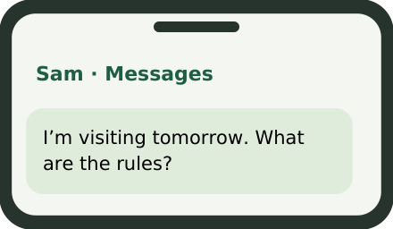
Reply to Sam. Write three short sentences about Green Door Studio. Use must / have to, mustn’t and don’t have to.
__________________________________________________________________
__________________________________________________________________
__________________________________________________________________

Teacher notes and answers
RUL1 · A2–B1 · Adults and teens · About 40–50 minutes · No audio needed
Keep it simple
Give learners pages 1–4. Page 5 is optional homework. Keep this answer page separate. The aim is to explain necessary, forbidden and optional actions, then ask about rules. All signs and messages are original examples in a fictional setting.
A straightforward route
1. Pictures (5–7 min): use page 1 as before. Ask what learners see, what the problem is and what rule might help. Pictures suggest problems; they do not prove a rule. 2. Language (8–10 min): read page 2 together. Check “Do you have a choice?” Accept must and have to for a necessary action. 3. Messages (10–12 min): learners check Alex’s four texts against the signs, compare answers, then ask and answer the four questions. Swap who asks. One-to-one, take the other role. 4. Speaking (15–20 min): choose a page-4 place and agree three rules. Then use the questions for personal conversation. Give one useful correction and let the learner try again.
The language to make clear
Must / have to: both express necessity. Have to often reports a rule; must often gives a firm instruction. This is a tendency, not a strict division. Do not mark a natural alternative wrong. Mustn’t: forbidden. Don’t have to: not necessary, but allowed. Ask: “Can I still wear a badge?” Yes. Forms: Sam has to; Does Sam have to…? Sam doesn’t have to. Must stays the same with all subjects and takes no to. This lesson covers present obligation, not deduction or past forms.
Answers
Page 2: 1 don’t have to; 2 mustn’t; 3 must; 4 has to. Page 3: 1 You must / have to sign in. 2 Correct. 3 You don’t have to bring your own laptop; you can borrow one. 4 You don’t have to wear a badge; you may wear one if you like. The garden is the supplied place for calls. Accept accurate paraphrases. Page 5: 1 must / have to; 2 mustn’t; 3 don’t have to; 4 must / has to; 5 doesn’t have to; 6 don’t have to; 7 You must sign in. 8 Does Sam have to wear a badge? A possible reply: You have to sign in. You mustn’t make calls in the workroom. You don’t have to bring a laptop. Other accurate replies are welcome.
Support and follow-up
For a shorter lesson, use pages 1–3 and two speaking questions. Allow thinking time and keep page 2 visible. Stronger learners can explain or challenge a rule. Page-4 rules and discussion have no single answer: listen for a clear meaning and a sensible reason. No booking puzzle, private sheets or surprise change is needed. Timing is an estimate; this revision has not been classroom tested.
Grammar reference: British Council, Modals: permission and obligation. learnenglish.britishcouncil.org/free-resources/grammar/b1-b2/modals-permission-obligation

